In dialogue with Enlightenment thinkers
In dialogue with Enlightenment thinkers |  | Video question

Name︰_______________ （ ） Class︰__________

Related Textbook Content | 2A pp.35-37

Watch the video below and answer the following questions.

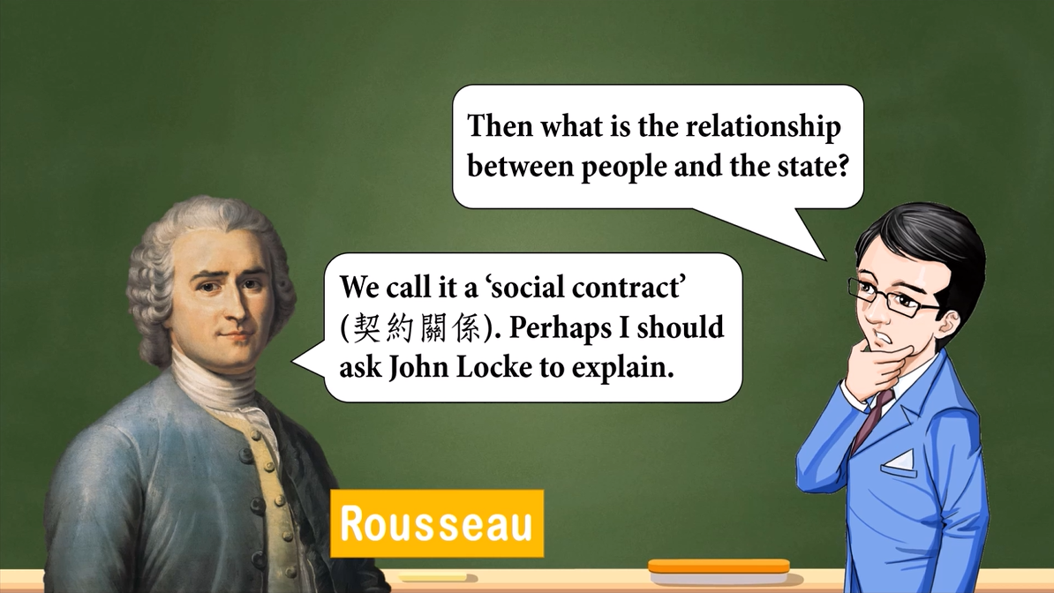
Link: https://youtu.be/lQv1rcBSGIA  Duration: 2m56s  Introduction: Introduce the theories of Enlightenment thinkers | 

Watch the video and fill in the blanks below.

1. Rousseau suggested that the ______________ belongs to the people. And the power of the ___________ is given by the people.

2. John Locke believed that all people have basic natural rights, which includes
______________, ______________ and ______________.

3. Montesquieu advocated that powers should be separated into ______________, ______________ and ______________ to counter-check each other. He also believed that the most ideal form of state is ____________________.

Answer the following questions with reference to the video.

4. According to John Locke’s perspective, how did the state and the people build a contract relationship?
________________________________________________________________________
________________________________________________________________________

5. In your opinion, what influence did the Enlightenment thinkers bring to the later generations? Explain your answer.
________________________________________________________________________
________________________________________________________________________
________________________________________________________________________

Answers

1. Rousseau suggested that the _____ sovereignty___ belongs to the people. And the power of the ____ monarchy___ is given by the people.

2. John Locke believed that all people have basic natural rights, which includes
____ life____, ______ liberty____ and _____ property___.

3. Montesquieu advocated that powers should be separated into ____ executive__,
____ judiciary___ and _____ legislative___ to counter-check each other. He also believed that the most ideal form of state is ____democratic republic__.

4. People give the ruling power to the state to protect their natural rights, whil ethe state has the responsibility to protect people’s rights.

5. Any reasonable answer. Suggested answer: Lots of modern political ideologies claimed that they were inspired by the Enlightenment thinkers.

